The absorption and emission cross section using plot digitizer: 1
Ppump and Psout Vs fiber length at wavelength 1550 nm: 2
Gain Vs fiber length at different pump power: 3
Psout Vs Psin & Gain Vs Psin: 4
Gain Vs lamda(C-band) at Ppump= 0.5w and Psin= 1mw : 5
Psout with ASE Vs lamda(C-band): 6
clc
clear
close all
r=5e-06;
gammap=0.4;
gammas=0.8;
N=1e25;
A=pi.*r^2;
lamdap=1480e-09;
segmaep=0.7899e-25;
segmaap=1.950e-25;
lamdas=1550e-09;
segmaes=3.084e-25;
segmaas=2.277e-25;
t=10e-03;
c=3e8;
h=6.626e-34;
deltalamda=0.1e-09;

The absorption and emission cross section using plot digitizer:
[v1,T1,vT1]=xlsread('data1.xlsx');
x1=v1(:,1);y1=v1(:,2);
figure
plot(smooth(x1),smooth(y1),'b','linewidth',2)
hold on
[v2,T2,vT2]=xlsread('data2.xlsx');
x2=v2(:,1);y2=v2(:,2);
plot(smooth(x2),smooth(y2),'r','linewidth',2); grid on;
xlabel('wavelength(nm)');
ylabel('10^-21 cm^2');
legend('abs. cross section','em. cross section')
title('The absorption and emission cross section using plot digitizer')
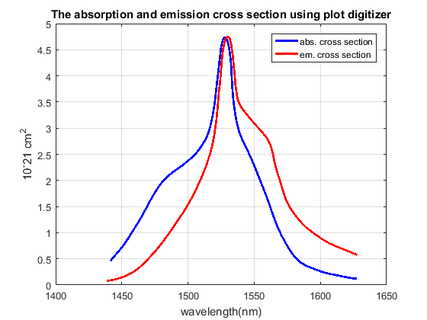

Ppump and Psout Vs fiber length at wavelength 1550 nm:
psindB=-40:10:10;
psin=10.^(psindB./10)*10^-3;
Ppump_in=[0.5 0.001];
[l,p]=ode45('dP_dz',(0:50),Ppump_in);
[maxValue,maxIndex]=max(p(:,2));
[maxValuep,maxIndexp]=max(10*log10(p(:,2)./0.001));
figure
plot(l,p(:,1),'linewidth',1.5);
hold on
plot(l,p(:,2),'linewidth',1.5);
xlabel('fiber length(m)');
ylabel('optical powers(W)');
legend('Ppump','Psout')
title('Ppump and Psout Vs fiber length at wavelength 1550 nm')
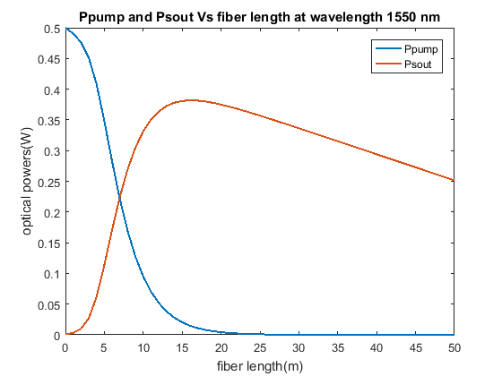

Gain Vs fiber length at different pump power:
ppump=0.1:0.1:0.5;
figure
hold on
for j=1:1:length(ppump)
Ppump_in=[ppump(j) 0.001];
[l,p]=ode45('dP_dz',(0:50),Ppump_in);
gainp=(p(:,2)./0.001);
gainpdB=10*log10(gainp);
plot(smooth(l),smooth(gainpdB),'linewidth',1.5)
end
optlength=l(maxIndexp);
plot(optlength,maxValuep,'*','linewidth',1.5)
hold off
xlabel('fiber length(m)');
ylabel('Gain(dB)');
legend('Ppump=0.1','Ppump=0.2','Ppump=0.3',...
'Ppump=0.4','Ppump=0.5','opt.length=15.8811 m')
title('Gain Vs fiber length at different pump power')
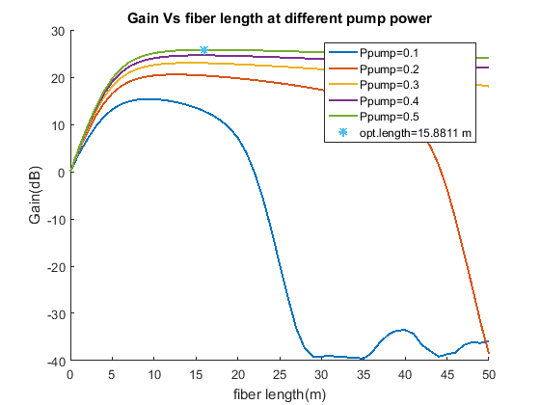

Psout Vs Psin & Gain Vs Psin:
psindB=-40:1:40;
psin=10.^(psindB./10)*10^-3;
psout=[];
Gain=[];
for i=1:1:length(psin)
Ppump_in=[0.5 psin(i)];
[l,p]=ode45('dP_dz',(0:50),Ppump_in);
if psin(i)<= 0.001
psout=[psout max(p(:,2))];
elseif psin(i)> 0.001
psout=[psout p(maxIndex,2)];
else
end
psoutdB=10*log10(psout);
Gain=[Gain (psout(i)./psin(i))];
GaindB=10*log10(Gain);
end
figure
semilogy(smooth(psin),smooth(psout),'linewidth',1.5)
xlabel('Psin(w)');
ylabel('Psout(w)');
title('Psout Vs Psin')
ylim([min(psout) max(psout)])
figure
semilogy(smooth(psindB),smooth(GaindB),'linewidth',1.5)
xlabel('Psin(w)');
ylabel('Gain(dB)');
title('Gain Vs Psin')
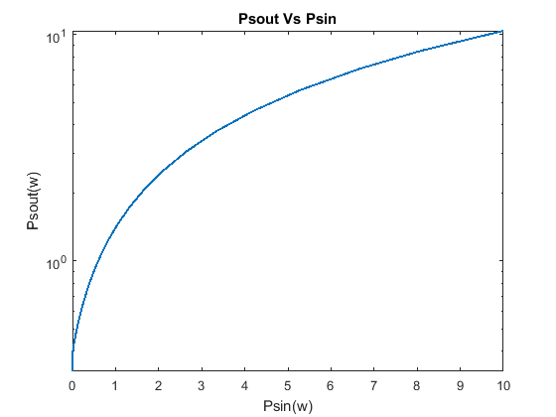
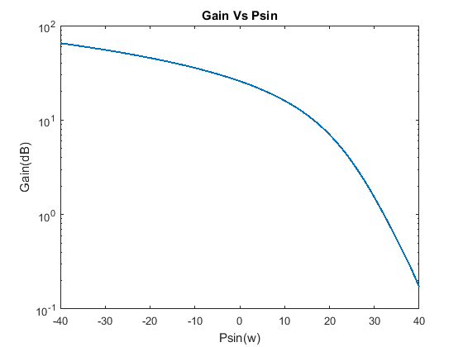

Gain Vs lamda(C-band) at Ppump= 0.5w and Psin= 1mw :
[v,T,vT]=xlsread('abs_em_values.xlsx');
x=v(:,1);y=v(:,3); z=v(:,2);
Ppump_in=[0.5 0.001];
gains=[];
lamda=x;
segmae=y;
segmaa=z;
pnoise=[];
for n=1:1:length(x)
[l,ps] = ode45(@(l,ps) dP_dzs(l,ps,x(n),y(n),z(n),lamda,segmae,segmaa)...
,(1:1:50),Ppump_in);
gains=[gains ps(:,2)./0.001];
gainsdB=abs(10*log10(gains));
end
maxgainsdB=[];
for a=1:1:length(x)
maxgainsdB=[maxgainsdB max(gainsdB(maxIndexp,a))];
end
Lamada=(1525:0.05:1565).*10^-9;
GainsdB=interp1(x,maxgainsdB,Lamada,'spline');
figure
plot(smooth(Lamada),smooth(GainsdB),'linewidth',1.5)
xlabel('wavelength(nm)');
ylabel('Gain(dB)');
title('Gain Vs lamda(C-band) at Ppump= 0.5w and Psin= 1mw')
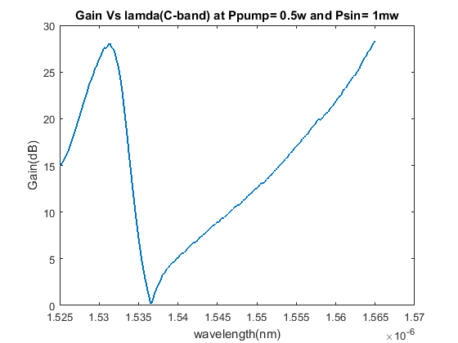

Psout with ASE Vs lamda(C-band):
pp=zeros(1,401);
pp(301)=0.001;
for n=1:1:length(x)
P=[0.5 pp(n)];
[l,pn] = ode45(@(l,pn) dP_dzn(l,pn,x(n),y(n),z(n),lamda,segmae,segmaa),(1:50),P);
pnoise=[pnoise pn(maxIndexp,2)];
pnoisedB=10*log10(pnoise);
end
figure
loglog(x,pnoisedB,'linewidth',1.5)
xlabel('wavelength(nm)');
ylabel('Optical power(dBm)');
title('Psout with ASE Vs lamda(C-band)')
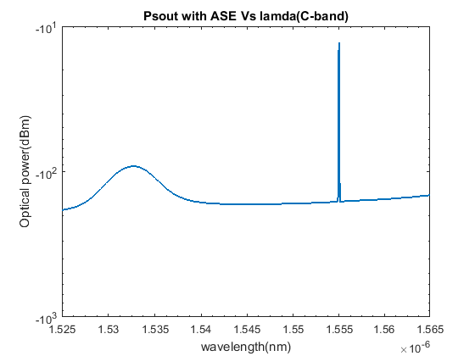

Published with MATLAB® R2016a

